**Ideation Phase – II**

Data Flow Diagrams and User Stories

|  |  |
| --- | --- |
| Date | 29 October 2022 |
| Team ID | PNT2022TMID05666 |
| Project Name | Smart Waste Management System For Metropolitan Cities |
| Maximum Marks | 4 Marks |

**Data Flow Diagrams:**

A Data Flow Diagram (DFD) is a traditional visual representation of the information flows within a system. A neat and clear DFD can depict the right amount of the system requirement graphically. It shows how data enters and leaves the system, what changes the information, and where data is stored.

**Diagram:**

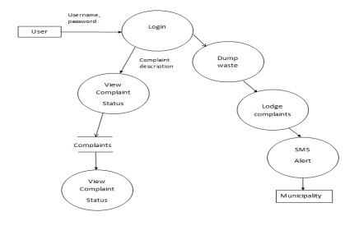

Dataflow Diagram for users of Smart Wastebin

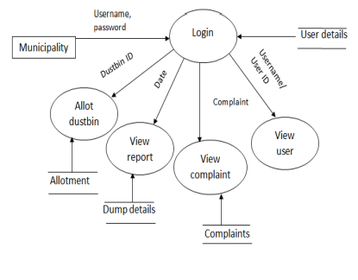**Diagram:**

Dataflow Diagram for Municipality of Smart Wastebin

**User Stories:**

|  |  |  |  |  |  |
| --- | --- | --- | --- | --- | --- |
| User type | Function requirement  (Epic) | User Story number | User story/Task | Acceptance Criteria | Priority |
| Admin(who manage web server) | Login | USN-1 | As an admin I gave user ID and password for workers and manage them | I can manage web account/ dashboard | Medium |
| Truck driver | Login | USN-2 | As a truck driver I follow the route send by co admin | I can drive to reach the garbage filled route in shortest route given | Medium |
| Local garbage collector | Login | USN-3 | As a waste collector I collect all the trash from garbage and send them to landfill | I can collect trash and pulled to truck and send off | Medium |
| Municipality | Login | USN-4 | As a municipality I check all the processes that are happening | I can manage all the processes going good | High |
| Co admin | Login | USN-5 | As a co admin I'll manage the garbage level monitor. | I can manage the garbage monitoring | High |